**Component NMA of psychotherapies for bipolar disorder**

**Contents**

1 **Depression** 2

1.1 Primary analysis 2

1.1.1 Network graph 2

1.1.2 Pairwise meta-analyses 3

1.1.3 Assessment of small study effects and publication bias (SSE) 5

1.1.4 Network meta-analysis – treatment level 6

1.1.5 Component NMA 8

1.2 Sensitivity analysis: component NMA accounting for SSE 10

1.3 Sensitivity analysis: imputing missing SDs and number of patients. 11

1.3.1 Pairwise analyses 11

1.3.2 NMA at the treatment level 13

1.3.3 NMA at the component level 16

1.4 Sensitivity analysis: analysing change from baseline 18

1.4.1 Pairwise meta-analyses 18

1.5 Notes 19

2 **Mania** 20

2.1 Primary analysis 20

2.1.1 Treatment-level network graph 20

2.1.2 Pairwise meta-analyses 20

2.1.3 Assessment of small study effects and publication bias (SSE) 22

2.1.4 Network meta-analysis 23

2.1.5 Component NMA 25

2.2 Sensitivity analysis: imputing missing number of patients. 27

2.2.1 Pairwise comparisons 27

2.2.2 Assessment of SSE and PB 29

2.2.3 NMA at the treatment level 30

2.2.4 NMA at the component level 31

3 **Relapse** 32

3.1 Primary analysis 32

3.1.1 Treatment-level network graph 32

3.1.2 Pairwise meta-analyses 32

3.1.3 Assessment of small study effects and publication bias (PB/SSE) 34

3.1.4 Network meta-analysis – treatment level 35

3.1.5 Component NMA 37

3.2 Sensitivity analysis – complete case analysis 39

3.2.1 Treatment-level network graph 39

3.2.2 Pairwise meta-analyses 39

3.2.3 Assessment of small study effects and publication bias (PB/SSE) 41

3.2.4 Network meta-analysis – treatment level 42

3.2.5 Component NMA 44

4 **Dropout** 46

4.1 Treatment-level network graph 46

4.2 Pairwise comparisons 46

4.3 Network meta-analysis 49

4.4 Component-level NMA 50

Appendix 52

# **Depression**

For all analyses presented in Sections 1.1 and 1.2 we have excluded studies that do not provide the SDs or number of patients. Studies without number of patients were included in a sensitivity analysis (Section 1.4).

## **Primary analysis**

### **Network graph**

20 two-armed studies and 1 four-armed study were included in analyses of Section 1.1. Below we present the network graph. The thickness of the lines corresponds to the number of studies performing each treatment comparison. The size of the nodes corresponds to the number of studies comparing each treatment.

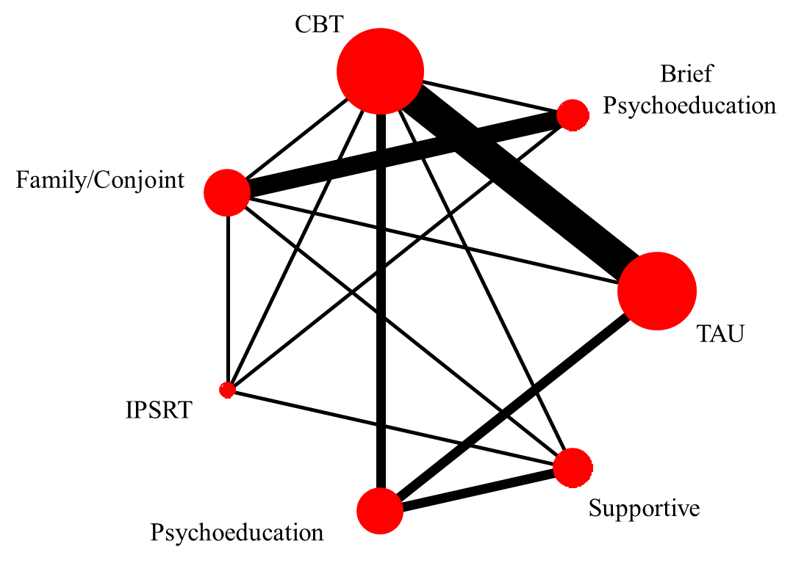

### **Study-specific estimates and pairwise meta-analyses**

In the next graphs we present all pairwise comparisons informed by multiple studies.

Figure 1: Brief Psychoeducation vs Family conjoint– pairwise meta-analysis

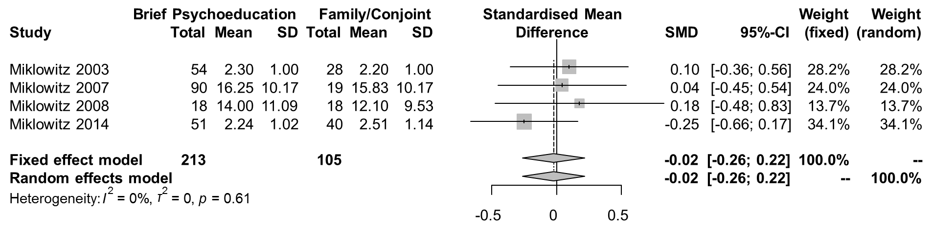

Figure 2: Psychoeducation vs Supportive – pairwise meta-analysis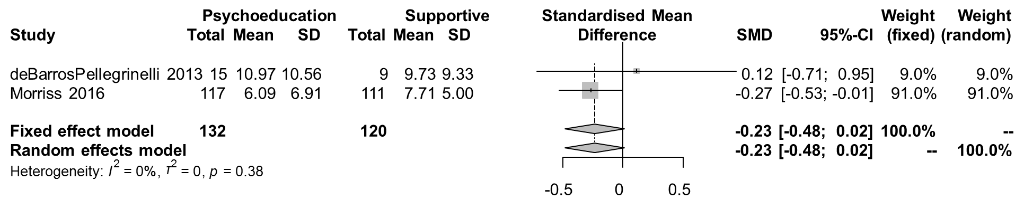

Figure 3: CBT vs Psychoeducation – pairwise meta-analysis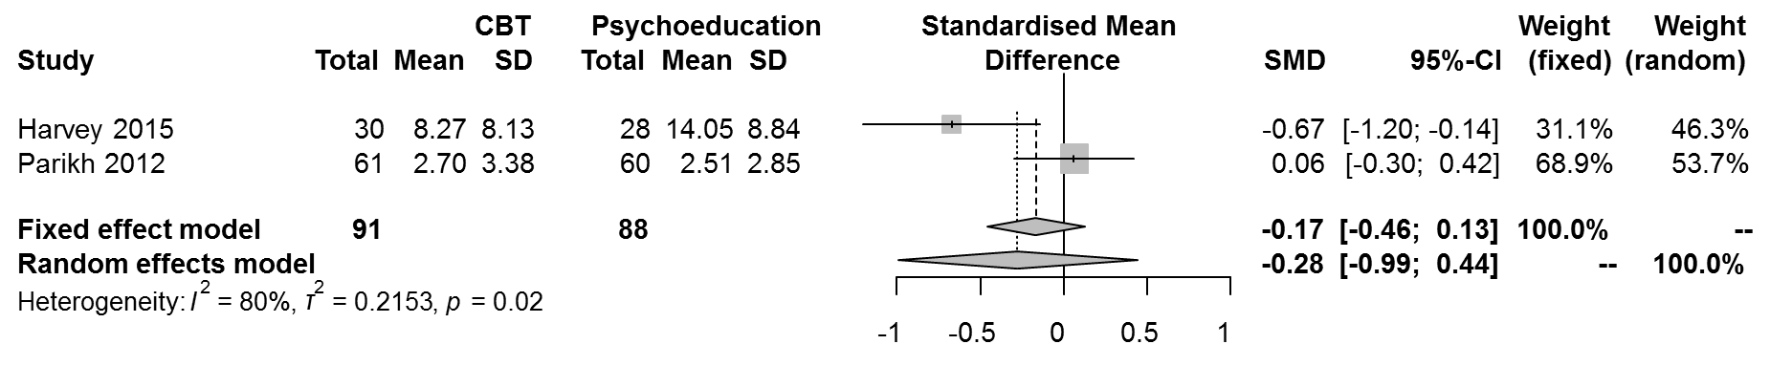

*Figure 4: CBT vs TAU – pairwise meta-analysis*

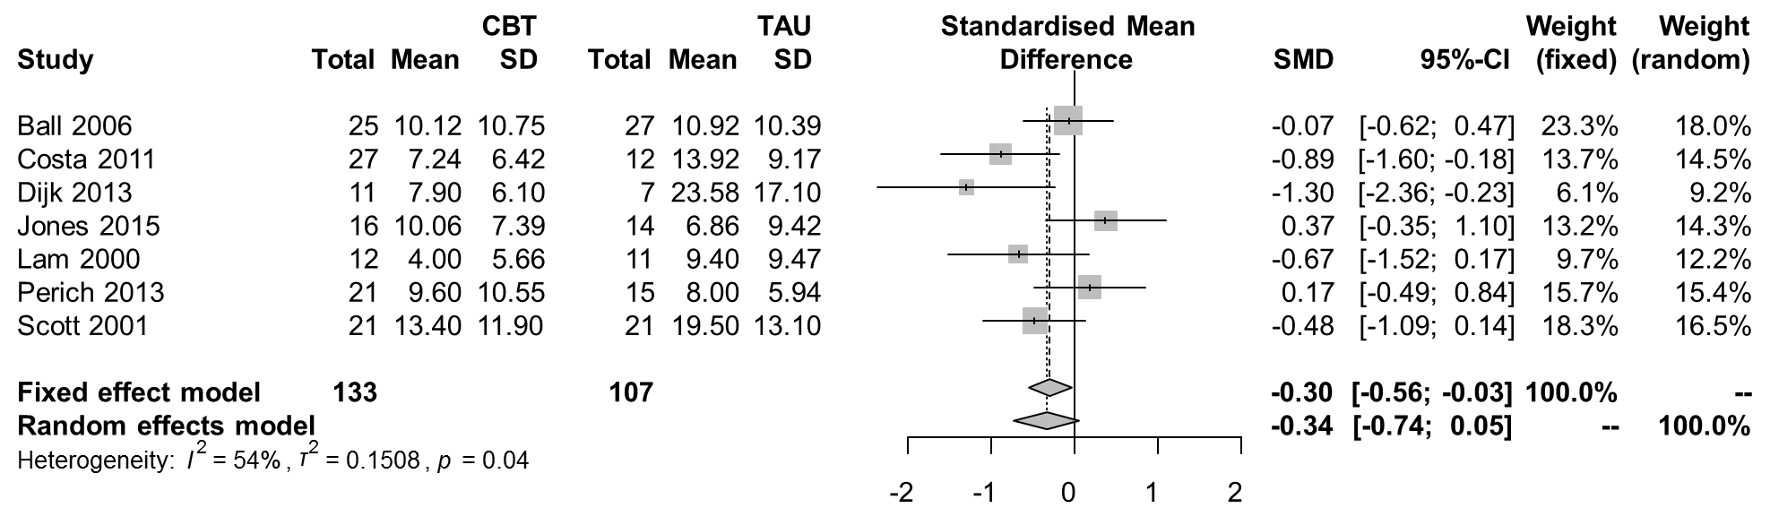

*Figure 5: Psychoeducation vs TAU – pairwise meta-analysis*

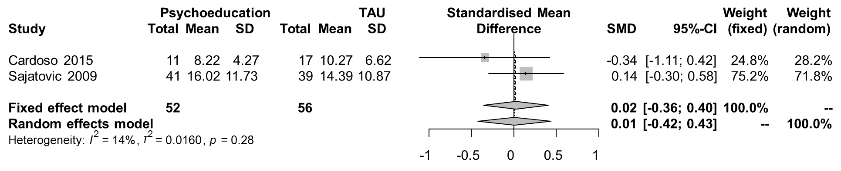

### **Assessment of small study effects and publication bias (SSE/PB)**

Note that in the forest plots above, in comparisons vs TAU the smaller studies show the largest effects favouring the active treatment. In order to check this hypothesis we group all treatments other than TAU. There are 10 studies comparing other treatments vs. TAU. Here is the funnel-plot:

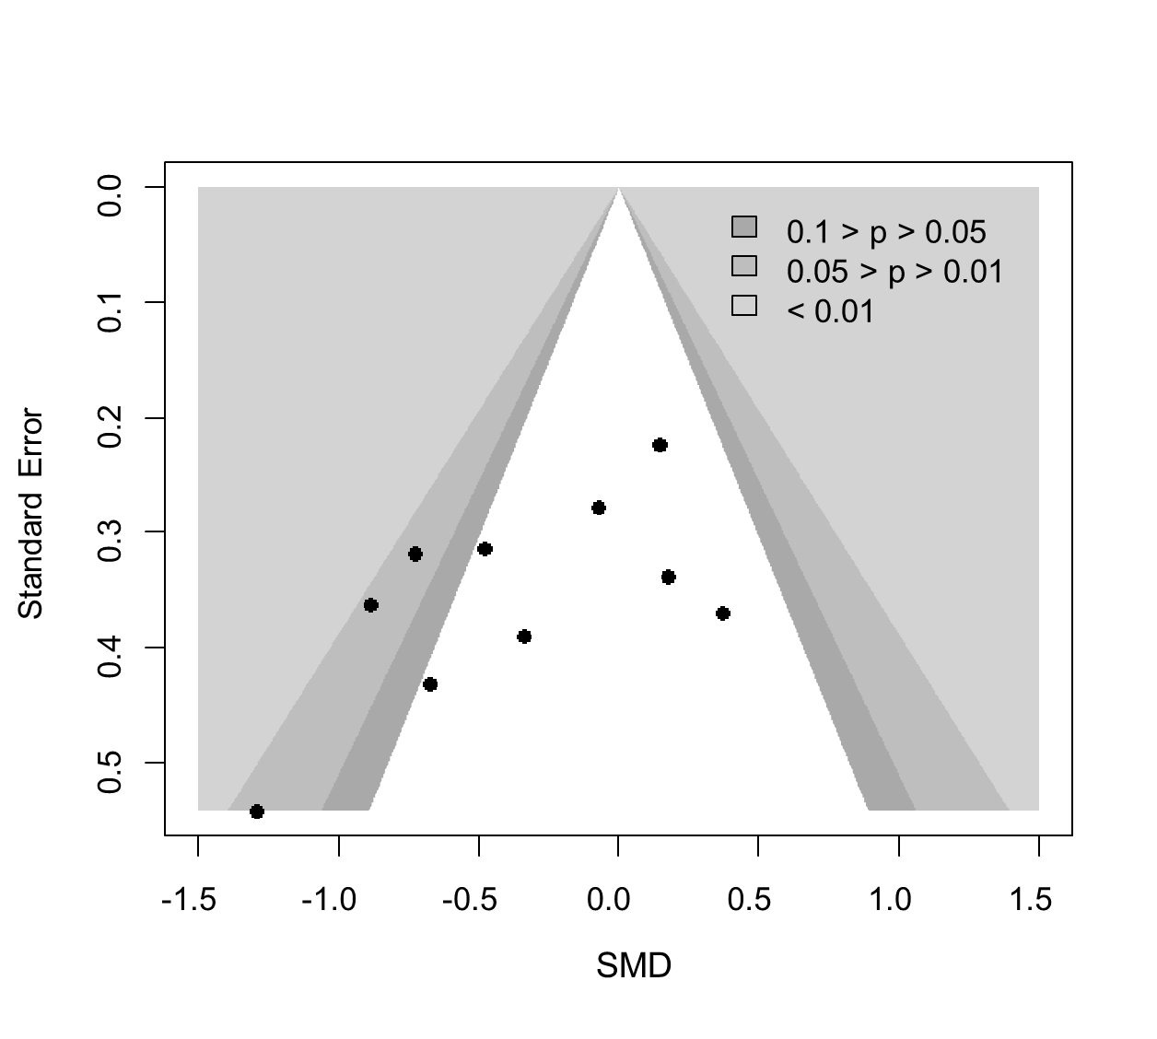

There is evidently an asymmetry in the funnel-plot. Egger’s test gives a p-value 0.07.

### **Network meta-analysis – treatment level**

Analysis was performed in R, using the netmeta command. The common $τ^{2}$ was estimated to be 0.10.

The **upper triangle** of the following table shows the direct evidence for the SMD for the treatment in the line vs. the treatment in the column. E.g. the SMD for group CBT vs TAU is -0.33, i.e. favouring group CBT (lower value in the symptoms’ scale).Thus, numbers smaller than 0 in the upper triangle favour the treatment in the row-defining treatment of each cell. Some cells are empty because there were no studies performing the corresponding comparison. Also note that results in the upper part of the table may not agree exactly with the pairwise meta-analyses of the previous section. This is because here we all pairwise analyses are performed using a common $τ^{2}$. This is used even in comparisons performed in a single study only.

The **lower triangle** shows the results from NMA. Again, numbers smaller than zero favour treatments in the column.

|  |  |  |  |  |  |  |
| --- | --- | --- | --- | --- | --- | --- |
| Brief Psychoed. | 0.16  [-0.56; 0.89] | 0.00  [-0.40; 0.40] | 0.15  [-0.57; 0.88] | . | . | . |
| -0.08  [-0.63; 0.47] | CBT | -0.12  [-0.95; 0.71] | -0.01  [-0.76; 0.75] | -0.26  [-0.80; 0.28] | 0.68  [-0.13; 1.48] | -0.33  [-0.69; 0.03] |
| 0.06  [-0.33; 0.45] | 0.14  [-0.38; 0.66] | Family/  Conjoint | 0.11  [-0.72; 0.94] | . | -0.74  [-2.23; 0.75] | -0.73  [-1.61; 0.16] |
| 0.06  [-0.55; 0.66] | 0.14  [-0.43; 0.70] | -0.01  [-0.61; 0.60] | IPSRT | . | -0.11  [-0.86; 0.63] | . |
| -0.21  [-0.84; 0.42] | -0.13  [-0.51; 0.25] | -0.27  [-0.87; 0.32] | -0.27  [-0.88; 0.35] | Psychoed. | -0.15  [-0.72; 0.42] | -0.04  [-0.64; 0.57] |
| -0.09  [-0.72; 0.54] | -0.01  [-0.47; 0.45] | -0.15  [-0.75; 0.45] | -0.14  [-0.70; 0.42] | 0.12  [-0.33; 0.57] | Supportive | . |
| -0.40  [-0.99; 0.18] | -0.32  [-0.64; -0.01] | -0.46  [-1.01; 0.08] | -0.46  [-1.07; 0.15] | -0.19  [-0.60; 0.22] | -0.31  [-0.83; 0.20] | TAU |

The ranking of the treatments using p-scores (similar to SUCRAs) are as follows

|  |  |
| --- | --- |
| **Treatment** | **SUCRA** |
| IPSRT | 75% |
| Family/Conjoint | 68% |
| CBT | 61% |
| Brief Psychoeducation | 55% |
| Psychoeducation | 49% |
| Supportive | 36% |
| TAU | 6% |

Assessing Inconsistency

The design-by-treatment interaction model for inconsistency is calculated to be 6.12 (6 degrees of freedom), giving a p-value of 0.41.

The back-calculation method gave the following results:

**comparison k prop nma direct indir. Diff z p-value**

Brief Psychoeducation:CBT 1 0.58 -0.08 0.16 -0.41 0.57 0.99 0.3198

Brief Psychoeducation:Family/Conjoint 4 0.94 0.06 0.00 1.03 -1.02 -1.22 0.2237

Brief Psychoeducation:IPSRT 1 0.70 0.06 0.15 -0.17 0.32 0.48 0.6326

CBT:Family/Conjoint 1 0.40 0.14 -0.12 0.31 -0.43 -0.79 0.4286

CBT:IPSRT 1 0.56 0.14 -0.01 0.32 -0.32 -0.55 0.5815

CBT:Psychoeducation 2 0.50 -0.13 -0.26 -0.01 -0.25 -0.65 0.5171

CBT:Supportive 1 0.33 -0.01 0.68 -0.35 1.02 2.04 0.0413

CBT:TAU 7 0.76 -0.32 -0.33 -0.29 -0.04 -0.11 0.9104

Family/Conjoint:IPSRT 1 0.53 -0.01 0.11 -0.14 0.25 0.40 0.6856

Family/Conjoint:Supportive 1 0.16 -0.15 -0.74 -0.03 -0.71 -0.85 0.3969

Family/Conjoint:TAU 1 0.38 -0.46 -0.73 -0.30 -0.42 -0.74 0.4592

IPSRT:Supportive 1 0.56 -0.14 -0.11 -0.18 0.07 0.12 0.9077

Psychoeducation:Supportive 2 0.62 0.12 -0.15 0.58 -0.73 -1.54 0.1238

Psychoeducation:TAU 2 0.46 -0.19 -0.04 -0.32 0.28 0.67 0.5020

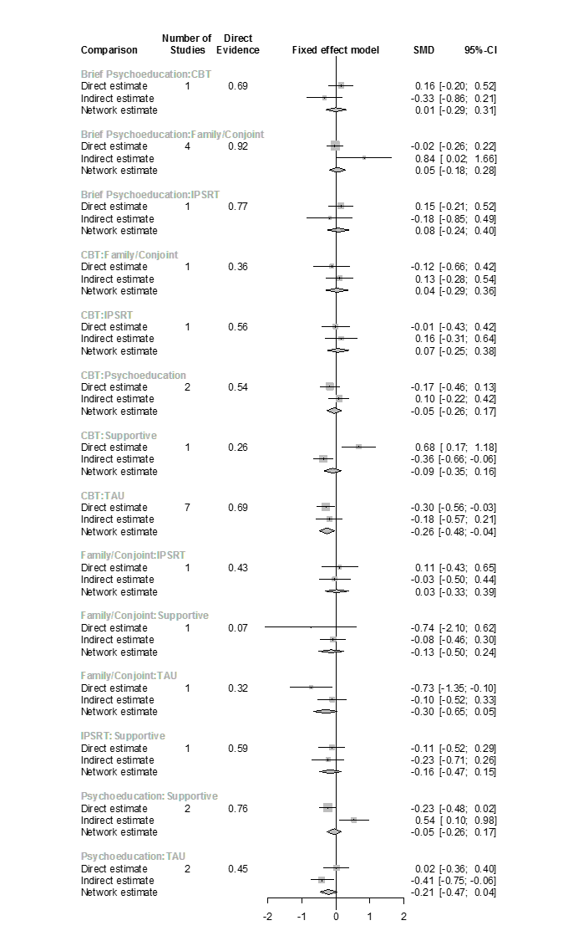

There is some evidence of inconsistency in the network. The most suspicious comparison is CBT:Supportive. The inconsistency is due to the Meyer 2012 study. This study has great imbalances in the baseline scores of each treatment arms.